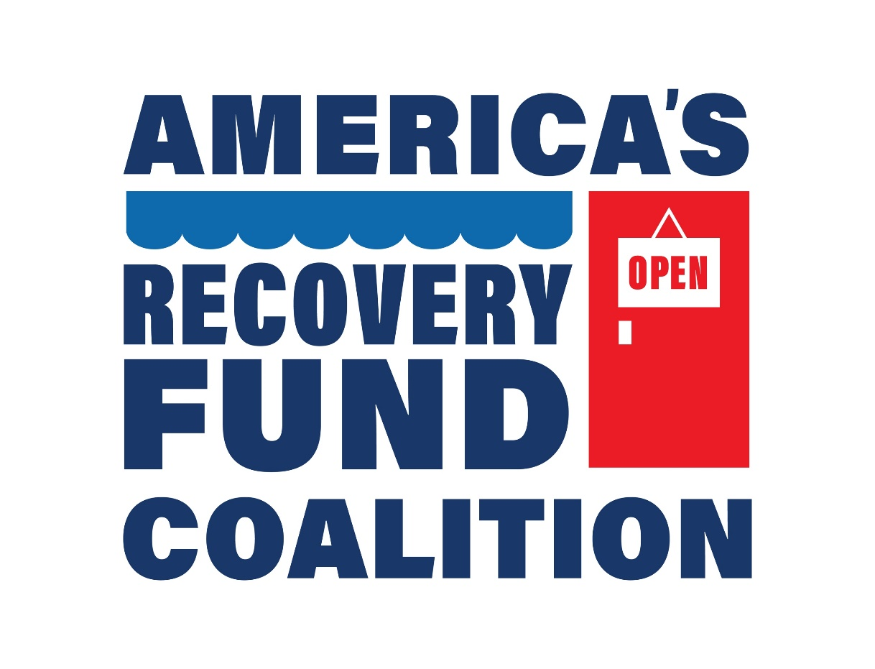
Open for Business Friday Toolkit

May 22, 2020
Last week, America’s Recovery Fund Coalition launched Open for Business Friday, a blog series that highlights the challenges different industries face as they look to open their doors, and keep them open, during the COVID-19 pandemic – and how a Recovery Fund will help them survive. To amplify this content, below is a toolkit with template social media and a template letter to the editor.

Sample Social Media

Sample Twitter Posts

- [XX] industry has made it through tough times before, but the economic fallout from #COVID19 is unprecedented. To help businesses and employees through, we need America’s Recovery Fund. Read the latest Open for Business Friday blog to learn why now is the time for big, bold thinking. @ARFCoalition https://bit.ly/36yFf6F

- [XX] industry is a critical part of the American economy – and if the economy is going to recover, we can’t forget about these businesses and employees. Read @ARFCoalition’s latest Open for Business Friday blog to learn about how a Recovery Fund could help the [XX] industry. https://bit.ly/36yFf6F

- More than [INSERT NUMBER] of employees make up the [XX] industry – and they need Congress’ support now to create America’s Recovery Fund and get our economy back up and running. Read more: https://bit.ly/36yFf6F @ARFCoalition

- [INSERT BUSINESS] is proud to be a part of @ARFCoalition’s Open for Business Friday. The [XX] industry accounts for [INSERT NUMBER] jobs in [STATE], and we need Congress to pass a Recovery Fund to protect our employees’ futures. https://bit.ly/36yFf6F

- The #COVID19 pandemic has been hard for businesses everywhere, including [INSERT BUSINESS], but we’re taking proactive action with @ARFCoalition to get the economy back on track. Read more about our work together on behalf of the [XX] industry: https://bit.ly/36yFf6F

Sample Facebook Posts

- No business is immune to the effects of COVID-19 and small businesses have been hit particularly hard. They need a long-term, thoughtful solution. Read @AmericasRecoveryFund’s latest Open for Business Friday highlighting [XX] industry to learn why more than 100 members are asking Congress to take action and create America’s Recovery Fund to bring our economy and country back. https://bit.ly/36yFf6F

- It’s Open for Business Friday! Nearly 39 million Americans are unemployed. Congress needs to take action so businesses can cover essential operating costs, rehire employees, adapt to new operations, and deliver what their customers need – safely, across industries so doors can remain open. American needs to get back to work! Read the latest @AmericasRecoveryFund’s Open for Business Friday blog. https://bit.ly/36yFf6F

Sample Letter to the Editor

The COVID-19 pandemic has hit the American economy like a wrecking ball, leaving businesses and employees everywhere facing a new reality few were prepared to weather. For the [XX] industry, the economic fallout has hit [INSERT LOCATION] particularly hard.

[INSERT LOCATION/INDUSTRY SPECIFIC EXAMPLE]

Being either unable to open or operating at a significantly reduced capacity means small business owners are having to look at alternative ways to keep their doors open as stay-at-home orders are lifted across the country. While many have sought support through the Paycheck Protection Program (PPP), it’s clear that will not go far enough to protect the [XX] industry.

That’s why I’m calling on [INSERT MEMBER OF CONGRESS] to create America’s Recovery Fund now. This grant-based program will provide financial assistance to help America’s businesses retain and rehire staff, pay rent, adapt to new requirements, meet certain debt obligations, and pay state and local taxes. It will be a vital lifeline to the [XX] industry. These times are tough – but our people are tougher, and America’s Recovery Fund would help businesses and communities navigate an ever-evolving environment.

