SOCIETY OF COLLISION REPAIR SPECIALISTS
Toll Free Phone (877) 841-0660 • Toll Free Fax 877-851-0660
Website: www.scrs.com • E-Mail: info@scrs.com • Mailing: P.O. Box 909, Prosser, WA 99350

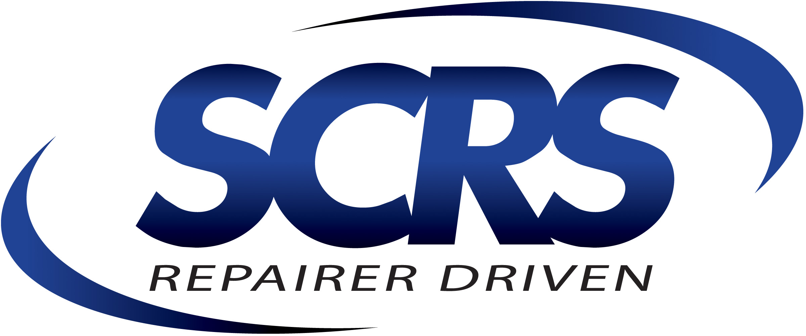
Executive Officers:
KyeYeung (714) 957-1290
Chairman California

Brett Bailey (816) 741-6966 Vice-Chairman Missouri

Bruce Halcro (406) 442-8611
Secretary Montana

Amber Alley (415) 994-7913
Treasurer California

Michael Bradshaw (828) 569-1275
Director-at-Large North Carolina

Andy Dingman (402) 558-3500
Immediate Past Chairman Nebraska

National Directors:
Michael Bradshaw (828) 569-1275
North Carolina

Domenic Brusco (724) 931-3063
Pennsylvania

Trace Coccimiglio (801) 576-8585
Utah

Dave Gruskos (732) 747-1770
New Jersey

Jeff Kallemeyn (630) 257-2277
Illinois

Matthew McDonnell (406) 259-6328
Montana

Paul Sgro (732) 222-3644
New Jersey

Timothy Ronak (949) 289-3357
California

Executive Director:
Aaron Schulenburg (302) 423-3537
Executive Director Delaware

Corporate Members
1-800-Radiator & AC
3M Automotive Aftermarket Div.
AkzoNobel
ALLDATA LLC
American Honda Motor Company

Arrowhead General Insurance Agency

Axalta Coating Systems

BASF Corporation
Capital One® Spark Business®
CAR-O-LINER Company
CCC Information Services Inc.
CELETTE, INC.
Chief Automotive Technologies
DeBeer Refinish
Diamond Standard Parts LLC
Elite Electronics
ENTERPRISE HOLDINGS
Fiat Chrysler Automobiles
Ford Motor Company
Ford Customer Service Division
Garmat USA
General Motors -
Customer Care & Aftersales
HUNTER Engineering Company
Hyundai Motor America
Intrepid Direct Insurance
KPAonline.com
LKQ CORPORATION
LORD Corporation
Matrix Electronic Measuring, Inc.
Mercedes-Benz USA, LLC
Miracle System/Equipment Gateway
Mitchell International
NAPA Paint & Supply-Martin Senour
NuGen IT
OEM Collision Repair Roundtable
PPG Industries
Saint-Gobain Abrasives, Inc.
Sherwin-Williams Automotive Finishes
THE HERTZ CORPORATION
Toyota Motor Sales, U.S.A., Inc.

[State Insurance Office] O-1505

Dear [Title Last Name],

I’d like to introduce myself as the executive director of the Society of Collision Repair Specialists (SCRS). Since 1982, SCRS has been the largest national trade association solely dedicated to representing hardworking collision repair facilities across North America, and I am writing to you today on behalf of our membership.

As a trade organization, our objective is to promote, support, and encourage exemplary businesses committed to performing proper repairs for the motoring public; and to offer information and leadership that aids the industry in upholding professionalism and commitment to quality.

In October of 2017, a Texas jury found a collision repair facility liable for $31.5M in compensatory damages as a result of repairs that did not follow documented repair procedures provided by the Original Equipment Manufacturer (OEM.) The size of the SEEBACHAN v. JOHN EAGLE COLLISION CTR decision, the fact that it was not for punitive damages, and the fact that it could have been mitigated had the facility followed OEM procedures, have all generated a significant amount of industry discussion. It is the position of SCRS that if an OEM documents a repair procedure as required, recommended or otherwise necessary as a result of damage or repair, that those published procedures would be the standard of repair until such time the documentation changes. Our position, communicated to our members, is that disregarding a documented procedure that is made available to the industry creates undue and avoidable liability on the repair facility performing the repair.

As part of our informational work on behalf of our members, we are trying to determine the role that your office plays in helping consumers ensure the claims settlement process will also ensure them a complete and proper repair. We hope that you can take a moment to respond to the following questions:

- Is your department charged with consumer protection and the entity who serves as the regulatory agency to govern and supervise the business of insurance in your state?
- Are claims settlement practices a part of that regulatory oversight?
- In many cases, vehicle manufacturers provide specific instructions and documented procedures on how repair and replacement operations are to be performed to produce a safe and proper repair. As evidenced in the SEEBACHAN v. JOHN EAGLE COLLISION CTR case in TX, failure of the facility performing the repair to follow these procedures can result in catastrophic loss, and incur avoidable liability that negatively impacts garage insurers.
Many state laws relevant to insurer claims settlement rely on subjective terms such as “reasonable” as a means of satisfying their obligations.
Is there anything that holds insurers and insurance policies sold in your state accountable to recognize manufacturer documented procedures as a basis for settling claims and loss indemnification?
- Would your department consider it a “reasonable” expectation that if an OEM repair procedure or instruction existed, that the claim should cover the associated costs?
- Would your department expect consumers to be clearly notified through exclusions in the policy where costs associated with documented OEM procedures would not be covered; otherwise, allowing a consumer to reasonably assume they would be?
- If there is a dispute between a consumer and their insurance carrier over the cost to restore their vehicle to pre-loss condition in accordance with manufacturer documented procedures, is your department the correct one to address those issues and provide consumer protection?
  - If yes, please explain?
  - If no, who is the appropriate consumer protection body to do so?

We would like to thank you in advance for your candor, and if you have any further questions, I can be reached at the contact information below.

Best regards,
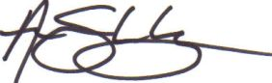
Aaron Schulenburg
SCRS Executive Director
302.423.3537 aaron@scrs.com

